# 5.2 Circular Trigonometry

## The Sine Function on the Unit Circle

In computer games, objects typically move up-and-down and left-to-right. These movements can be produced using the sine and cosine functions.

Draw a circle with radius 1 unit and on its circumference, place a point, let’s call it $P$.

The circle centered at the origin with radius 1 is called the unit-circle.

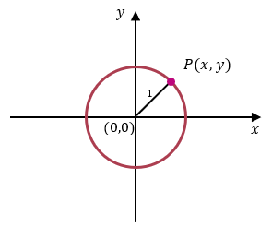

From our presentation of the sine and cosine function using right triangles, we can see that

$\sin{θ=\frac{opposite}{hypotenuse}=\frac{y}{1}=y}.$ That is, $y=\sin{θ}$.

This tells us that the sine of the angle $θ$ determines the vertical distance of the point $P$ from the horizontal axis.

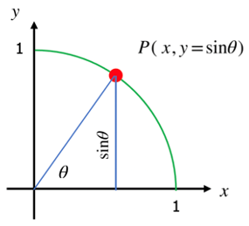

## The Cosine Function on the Unit Circle

To define cosine function, place a point $P(x,y)$ on the circumference of unit-circle.

Once again, from our presentation of the cosine functions using right triangles, we can see that

$\cos{θ=\frac{adjacent}{hypotenuse}=\frac{x}{1}=x}.$ That is, $x=\cos{θ}$.

This tells us that the cosine of the angle $θ$ determines the horizontal distance of the point $P$ from the vertical axis.

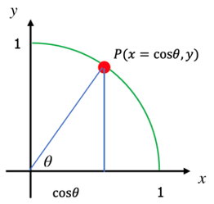

## The Sine and Cosine Functions on any Circle

We can extend this idea by making the radius of the circle $r$ units rather than just 1 unit.

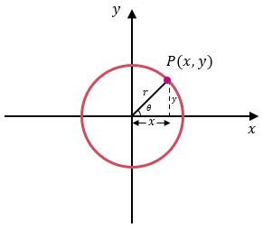

Using the same reasoning we just used with the unit circle, we see that

$$\sin{θ=\frac{opposite}{hypotenuse}=\frac{y}{r}} →r⋅\sin{θ}=y →y=r⋅sin{θ}$$

and

$$\cos{θ}{=\frac{adjacent}{hypotenuse}=\frac{x}{r} } → r⋅\cos{θ} → x=r⋅cos{θ}$$

which, again, tells us that the sine of the angle $θ$ determines the vertical distance of the point $P$ from the horizontal axis and that the cosine of the angle $θ$ determines the horizontal distance of the point $P$ from the vertical axis.

If $P$ represents an object, that object’s height $y$ off the ground (the horizontal axis) is given by $r⋅sin{θ}$, and that object’s horizontal distance $x$ from some reference point is given by $r⋅\cos{θ}$. The height of the object is controlled by some number $r$ times $\sin{θ}$, and its horizontal distance is controlled by some number $r$ times $\cos{θ}$.

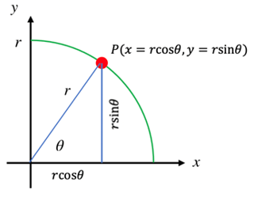

An object lies on the circumference of a unit circle. Find its coordinates if the line segment from the origin to the object makes angle of 30° with the horizontal.

Example (1)

|  |  |
| --- | --- |
| Because the object is on the circumference of unit circle, we can use $x=r\cos{θ}$ and $y=r\sin{θ}$, with $r=1$, $θ={30}^{∘}$. $$\begin{matrix}x=1cos30^{∘} and y=1sin30^{∘} \\ x=cos30^{∘} and y=sin30^{∘} \\ x=0.8660 and y=0.5\end{matrix}$$   The coordinates of the object are (0.8660, 0.5). | Object P on unit circle with angle 30 degrees with the horizontal. |

An object lies on the circumference of a circle of radius 5 cm. Find its coordinates if the line segment from the origin to the object makes angle of 40° with the horizontal.

Example (2)

|  |  |
| --- | --- |
| Because the object is on the circumference of circle of radius 5 cm, we can use $x=r\cos{θ}$ and $y=r\sin{θ}$, with $r=5$, $θ={40}^{∘}$. $$\begin{matrix}x=5cos40^{∘} and y=5sin40^{∘} \\ x=5\left(0.7660\right) and y=5(0.6428) \\ x=3.8302 and y=3.2139\end{matrix}$$   The coordinates of the object are (3.8302, 3.2139). | Object P on circle of radius 5 centimeter with angle 40 degrees with the horizontal. |

The coordinates of an object are (2.1, 3.6373). Find its distance from the origin.

Example (3)

We can use the Pythagorean Theorem, $a^{2}+b^{2}=c^{2}$, where $c$ is the hypotenuse, the radius of the circle in our case.

$$\begin{matrix}2.1^{2}+3.6373^{2}=r^{2} \\ 4.41+13.2300=r^{2} \\ 17.64=r^{2} \\ \sqrt{17.64}=\sqrt{r^{2}} \\ 4.2=r\end{matrix}$$

We conclude that the object is about 4.2 cm from the origin.

## EXAMPLES

1. An object lies on the circumference of a unit circle. Find its coordinates if the line segment from the origin to the object makes angle of 45° with the horizontal.

ANS: (0.7071, 0.7071)

1. An object lies on the circumference of a unit circle. Find its coordinates if the line segment from the origin to the object makes angle of 5° with the horizontal.

ANS: (0.9962, 0.0872)

1. An object lies on the circumference of a circle of radius 25 cm. Find its coordinates if the line segment from the origin to the object makes angle of 75° with the horizontal.

ANS: (6.4705, 4.8396)

1. An object lies on the circumference of a circle of radius 10 feet. Find its coordinates if the line segment from the origin to the object makes angle of 135° with the horizontal.

ANS: (-7.0711, 7.0711)

1. How high above the ground is an object that makes an angle of 60° with a 4-foot-tall observer’s eyes and is 35 feet away from that observer’s eyes? Round to two decimals place.

ANS: 34.31 ft

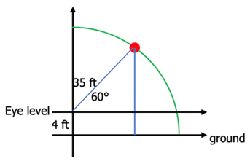

1. The coordinates of an object are (5.682, 2.0521). Find its distance from the origin if it makes an angle of 60° with the horizontal.

ANS: 6 units

## Note to the Instructor

We are using degrees rather than radians as most game players think in terms of degrees, not radians.

Consider demonstrating these examples:

1. An object lies on the circumference of a unit circle. Find its coordinates if the line segment from the origin to the object makes angle of 60° with the horizontal.

|  |  |
| --- | --- |
| Because the object is on the circumference of unit circle, we can use $x=r\cos{θ}$ and $y=r\sin{θ}$, with $r=1$, $θ={60}^{∘}$. $$\begin{matrix}x=1cos60^{∘} and y=1sin60^{∘} \\ x=cos60^{∘} and y=sin60^{∘} \\ x=0.5 and y=0.8660\end{matrix}$$   The coordinates of the object are (0.5, 0.8660). | Object on unit circle with angle 60 degrees with the horizontal. |

1. An object lies on the circumference of a circle of radius 25 m. Find its coordinates if the line segment from the origin to the object makes angle of 120° with the horizontal.

ANS: (-12.5, 21.6506)

1. How high above the ground is an object that makes an angle of 50° with a 3-foot-tall observer’s eyes and is 100 feet away from that observer’s eyes? Round to two decimals places.

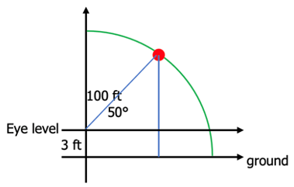

ANS: 79.60 ft

1. The coordinates of an object are (5, 12). Find its distance from the origin.

We can use the Pythagorean Theorem, $a^{2}+b^{2}=c^{2}$, where $c$ is the hypotenuse, the radius of the circle in our case.

$$\begin{matrix}5^{2}+12^{2}=r^{2} \\ 25+144=r^{2} \\ 169=r^{2} \\ \sqrt{169}=\sqrt{r^{2}} \\ 13=r\end{matrix}$$

We conclude that the object is about 13 units from the origin.

[5-2_circular_trigonometry.docx](https://oer4cte.org/math4gamedevelopers/teacher/5-2_circular_trigonometry.docx), attributed to Denny Burzynski (author) and Downey Unified School District (publisher) is licensed under CC BY-NC 4.0. To view a copy of this license, visit https://creativecommons.org/licenses/by-nc/4.0